Women’s Night

What: EACN Women’s Night

When: 1st Thursday of every month

Start Time: 6pm

Location: UF Health Family Medicine
1707 N. Main Street
Gainesville, FL 32609

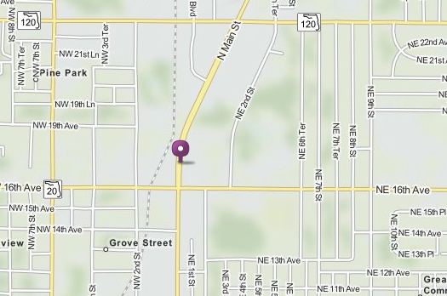

Notes for HOQI Volunteers:
- Appointments
  - Make through Practice Fusion
  - 8 appointments max per night
  - Remind patients that their spot will be given away if they do not arrive at the latest by 6:15pm.
- Walk-ins welcome (first come- first serve)
- Services offered (OB/GYN physician)
  - Basic female exams including pelvic​ and breast exams
  - Pap smears and GC/Chlamydia testing (can also be done on regular clinic nights)
  - Referral to Alachua County Health Department for further testing
  - Endometrial biopsies if needed
- Remind patients to arrive at least by 5:30pm (still not guaranteed a spot).

