Physical Therapy

What: EACN Physical Therapy Clinic

Who: Run by UF Doctor of Physical Therapy Students

When: Every Thursday

Time: 6-8pm

Location: CVS (Upstairs)
1621 SW 13th St. Gainesville, FL 32608
Entrance is on 13th St.
Across from Steak and Shake

Contact
Phone Number: 352-273-6112
E-mail: ufpteac@gmail.com
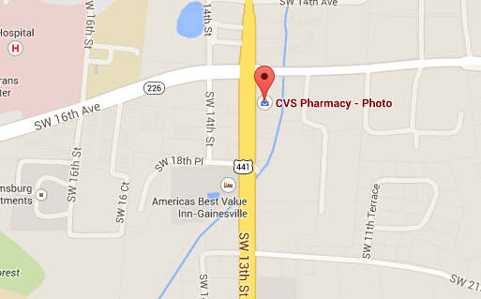

Notes for HOQI Volunteers:
- No appointments taken (first come- first serve)
- If patients have any questions, refer them to the phone number and email above.
- Referrals:
  - Patients are allowed to come to the clinic without a referral for the first two visits.
  - After the first two visits, they need to visit one of our clinics to fill out a PT Referral Form and get a physician signature.

