Ophthalmology Clinic

What: EACN Ophthalmology Clinic

When: Last Tuesday of every month

Time: 6pm

Location: Gainesville Community Ministry
238 SW 4th Avenue
Gainesville, FL 32601

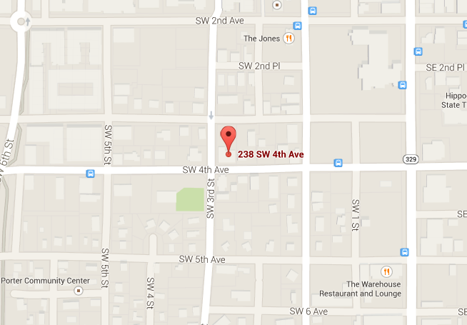

Notes for HOQI Volunteers:
- Appointments required, no walk-ins
  - Made through Practice Fusion
  - 6 max per night
  - If you make an appointment for a patient, please notify Jonathan Joseph (jonathan3295@ufl.edu) or Jacob Fant (jacobafant@ufl.edu).
- Ask patients to come in at 5:30pm
- Ideal for patients with these conditions:
  - Sudden decreased vision
  - Unexplained poor vision
  - Diabetic eye issues
  - Glaucoma

