Occupational Therapy

What: EACN Occupational Therapy Clinic

When: 1st and 3rd Thursday of every month

Time: 6-9pm

Location: UF Health Family Medicine
1707 N. Main Street
Gainesville, FL 32609

Contact
Phone Number: 352-273-6044
E-mail: equalaccessclinic.ot@gmail.com

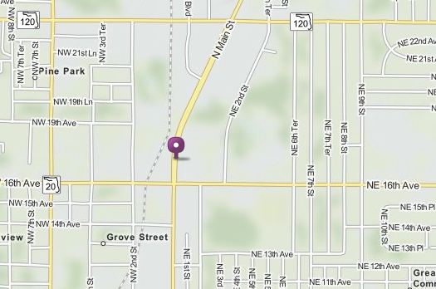

Notes for HOQI Volunteers:
- What is OT?
  - Occupation Therapists are trained to help people engage in everyday activities that they currently have difficulty completing. Examples include getting dressed, preparing meals, etc.
- Walk-ins welcome (first come- first serve)
- No appointments through us, ask the patient to call the number above.

