Free Therapy Night

What: EACN Free Therapy Night

When: Every Monday

Time: 5:30-7:30pm

Location: Gainesville Community Ministry
238 SW 4th Avenue
Gainesville, FL 32601

Contact
Phone Number: 352-325-1775
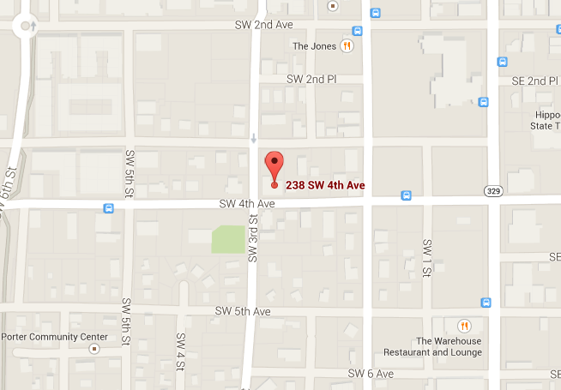

Notes for HOQI Volunteers:
- What is Free Therapy Night?
  - For patients who qualify: 30-40min clinical interview followed by 5 individual psychotherapy sessions
  - Patients can be seen for any number of mental health issues including PTSD, depression, anxiety, panic, and family or relationship stress.
- Referrals should only be given if the attending prescribes it or if the therapy screening questions indicate if it is appropriate.
- Appointments (preferred)
  - Ask patient to call the number above
- Walk-ins welcome (must arrive before 6:30pm)

