Diabetes Education

What: EACN Diabetes Education Classes

When: 2nd and 4th Thursday of each month

Time: 5pm

Location: UF Health Family Medicine
1707 N. Main Street
Gainesville, FL 32609

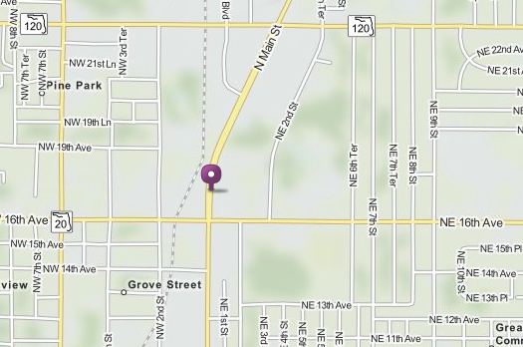

Notes for HOQI Volunteers:
- Appointments
  - Recommended
  - Made through Practice Fusion
  - No max appointments- any number of patients can sign up
- Topics alternate each week
  - Week 1: Blood sugar goals, what to do when you have high or low BP, how and when to test, how to manage complications
  - Week 2: Meal planning, portion sizes, carbohydrates, how to safely lose weight

