Sexually Transmitted Infection (STI) Testing
Resources in Alachua County

Alachua County Health Department
224 SE 24th Street, Gainesville, FL 32641; phone: (352) 334-7900
Website: http://www.doh.state.fl.us/chdalachua
- Tests Available:
  - HIV ($20, optional): confidential/anonymous; rapid (15 min)/conventional
  - STI panel (~$80 maximum; sliding scale): includes HIV, syphilis, gonorrhea, chlamydia, hepatitis panel
  - Herpes ($30)
- Appointments:
  - Call ahead:
    - HIV testing: (352) 334-7690
    - Other STI testing: (352) 334-7900
  - Walk in:
    - HIV testing: Monday – Friday, 9:00 – 4:00 PM
    - Other STI testing: Tuesday & Thursday, 12:30 – 3:00 PM
- What to bring to your appointment: call (352) 334-7900 for more details
  - Photo ID
  - Proof of residency
  - Proof of income/unemployment
  - Proof of scholarships/awards
  - Any insurance cards
- More information:
  - Staff speak English & Spanish
  - HPV vaccine (for ages < 19 yrs) & hepatitis B vaccine available
  - Test results only given in person; make follow-up appointment for results
  - Counseling & treatment for STIs provided at the follow-up appointment
  - All services available to adults & adolescents, regardless of citizenship status
  - Costs as shown above; all fees based on sliding scale system per patient income
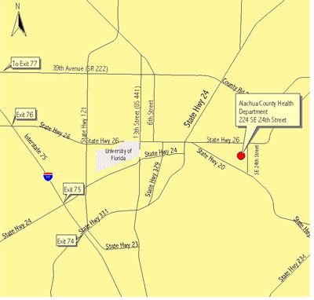

Planned Parenthood
914 NW 13th St, Gainesville, Florida 32601, phone: (352) 377-0881, 800-230-7526
Website: http://www.plannedparenthood.org/healthcenter/centerDetails.asp?f=2155&a=0&v=details
- Tests available:
  - Male package ($120): includes brief physical exam, plus gonorrhea/chlamydia/HIV western blot/syphilis testing
  - Female package ($130): includes brief physical exam, vaginal wet prep (candida/bacterial vaginosis/trichomonas), plus gonorrhea/chlamydia/HIV western blot/syphilis testing
  - Brief physical exam ($65): required before any testing; then pay per test/service:
    - Gonorrhea ($12.50)
    - Chlamydia ($12.50)
    - HIV rapid ($25)/HIV western blot ($20)/HIV swab (free; only Wed 12-2pm; may take up to 3 weeks for results)
    - Syphilis ($20)
    - Herpes type 1 ($25): blood test (IgG)
    - Herpes type 2 ($25): blood test (IgG)
    - Herpes, wound culture ($50): if patient has active Herpes break-out
    - Hepatitis C ($25)
- Vaccines:
  - HPV: 3 vaccine series; for ages 19-26 only
    - Free for patients with annual income < $21,000 & no health insurance
    - $210 for patients with annual income > $21,000 or health insurance
- Birth control:
  - Consultation ($55): required before birth control given; plus:
    - Oral contraceptive pills ($20 per month)
    - NuvaRing ($35 per month)
    - Mirena IUD ($600): contraception for 5 yrs; fee includes insertion
    - Paraguard IUD ($515): contraception for 10 yrs; fee includes insertion
    - Implanon ($650): contraception for 3 yrs; fee includes implantation
- Appointments: 9:45 – 6:00 pm, Monday – Friday; call ahead to schedule, (352) 377-0881
- More information:
  - Cost is fixed & is as listed above
  - Brief physical exam ($65) is required before other services may be obtained

Additional Resources/Information on STI’s:
- InSPOT Florida, http://www.inspot.org/Florida
If you can't tell them about an STD in person or over the phone, in Florida there is another option! Using inSPOT, you can send e-cards anonymously OR from your email address
- ASHA's STI Resource Center Hotline; (919)361-8488; http://www.ashastd.org/learn/learn_overview.cfm
The STI Resource Center Hotline is a program of the American Social Health Association (ASHA) that provides information, materials and referrals to anyone concerned about sexually transmitted infections (STI). Health Communication Specialists are on staff to answer STI questions on such topics as transmission, risk reduction, prevention, testing and treatment. The Hotline is open from 8:00 am to 6:00 pm, Eastern Time, Monday through Friday
- Florida Department of Health: http://www.cdc.gov/std/default.htm

