Free Talk Therapy & Behavioral Therapy

For qualifying diagnoses, patients receive 5 weeks of psychotherapy therapy. The first visit consists of a one-hour clinical interview followed by four weeks of intensive psychotherapy, psychoeducation, or family and marriage counseling  Walk-ins are welcome, but appointments can be made if desired (they are not required)  Appointment  Date __________ Time __________ |  | Patients can be seen at Free Therapy Night for:  1) Panic Disorder  2) Depression  3) Generalized Anxiety Disorder  4) Obsessive-Compulsive Disorder  5) Phobia  6) Hypochondriasis  7) Conversion Disorder  8) Somatization Disorder  Gainesville Community Ministries  238 SW 4th Ave. Gainesville, FL 32601  Every Monday from 5:30 pm - 7:30 pm
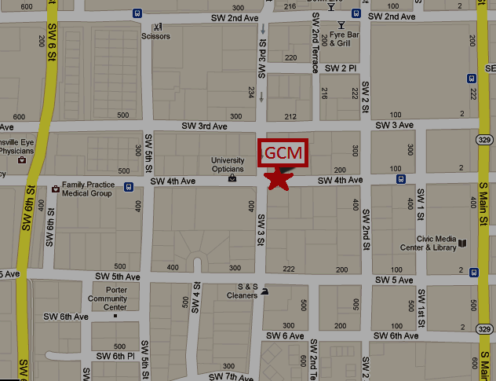
For Student Use
- If the patient knows the specific day they would like to attend physical therapy, an appointment can be scheduled (see the How to Guide for scheduling an appointment through Practice Fusion)
- If the patient does not know which day they would like to attend, they can go without an appointment. Advise walk in patients to arrive before the clinic opens as spots are limited
- Therapy referrals should only be given if the attending prescribes it or if the therapy screening questions indicate it is appropriate

