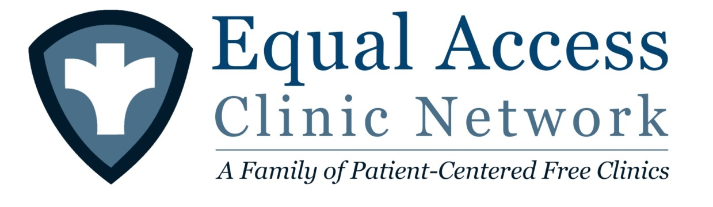
Volunteering Instructions for MS1s

Please don’t be intimidated! You can sign up at the very beginning of the year. You won’t be asked to do anything you aren’t comfortable with and we will pair you up with another student until you feel ready to see patients on your own. Getting an early start will help you learn how clinic works so you can hit the ground running once you have learned how to perform histories and physical exams.

MS1s must sign up in advance online before coming to Equal Access Clinic Network sites as space and the number of patients is limited. If you cannot make it to a date you are scheduled for, please unregister & tell your classmates there is an opening so that spots do not go unused. The online sign up for all 4 clinics can be found here https://medinfo.ufl.edu/cgi/signup.cgi

Make sure you bring your stethoscope & computer (needed to access online medical record)

For driving directions & other updates please visit the Equal Access Clinic Network website at http://equalaccess.med.ufl.edu/

Please arrive on time! Getting a late start means the patients and the attending physicians have to wait on us. Arriving late may also mean there aren’t any patients left for you to see

Equal Access at Tower Road (Monday Night)
Formerly known as Mobile West
Director | Kamil Nowicki
E-mail | kamko@ufl.edu
Contact Phone | (352) 317-7441
Location | Tower Road Library  3020 Southwest 75th Street  Gainesville, FL 32608
Hours | Monday Nights  Please Arrive at 6:00pm

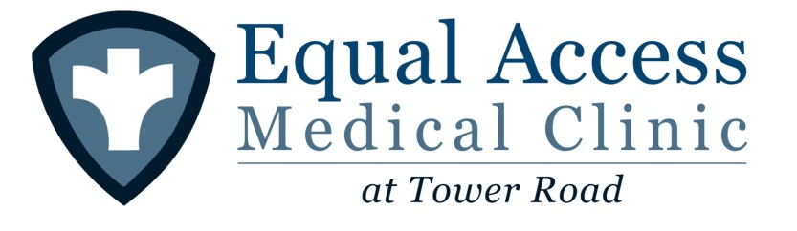
Equal Access at GCM (Tuesday Night)

Director | Aravind Reddy
Contact E-mail | aravind1023@ufl.edu
Contact Phone | 352-372-8162
Location | Gainesville Community Ministry (GCM)  238 SW 4th Ave.  Gainesville, FL 32601
Hours | Tuesday Nights  Please arrive at 5:00pm

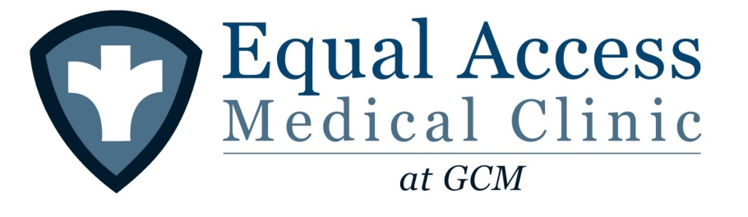

Equal Access at Bartley Temple (Wednesday Night)
Formerly known as Mobile East

Director | Brian McDaniel
Contact E-mail | Bpm08@ufl.edu
Contact Phone | 561-374-2004
Location | Bartley Temple United Methodist Church  1935 NE 8th Ave  Gainesville, FL 32641
Hours | Wednesday Nights  Please arrive at 6:00pm
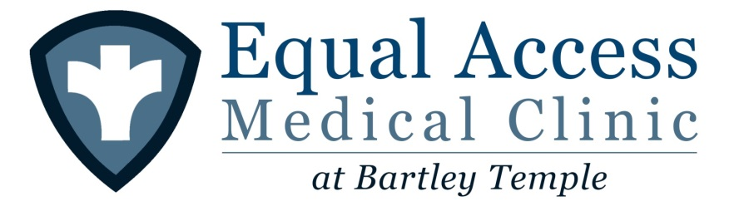

* If you have any questions you can also talk to Vishal Goswami (Class of 2017). He worked with Equal Access at Bartley Temple as an undergrad and is a current Equal Access officer who is familiar with all of our procedures

Equal Access at Main St. (Thursday Night)
Director | Ryan Carver
Contact E-mail | rcarver@ufl.edu
Contact Phone | (352) 327-8005
Location | 1707 N. Main Street  Gainesville, FL 32609
Hours | Thursday Nights  Please arrive by 6:00pm

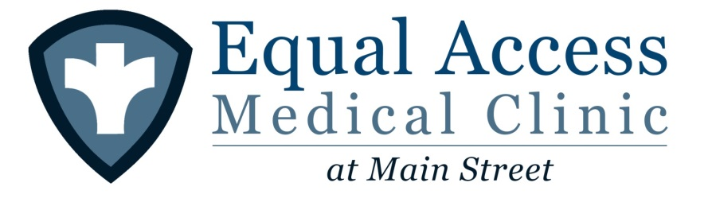

Thanks. Hope to see you all real soon!

